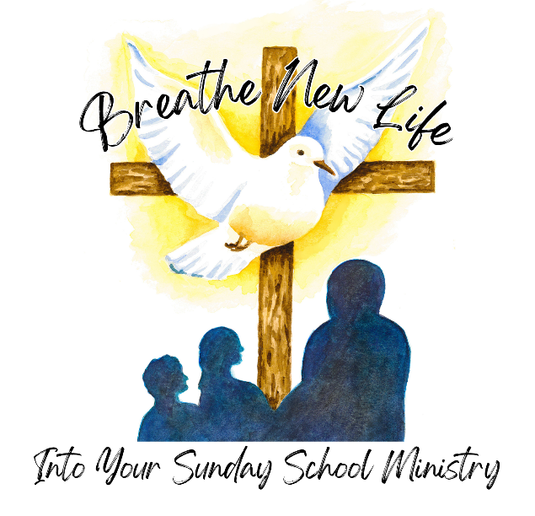
Sample Social Media Posts

Breathe new life into your Sunday School ministry by attending the 2024 WELS Western Wisconsin District Sunday School Conference. Register today! https://www.discipleshipwwd.org/2024-sunday-school-conference

Do you teach Sunday School, have ever taught Sunday School or just have interest in learning more ideas to improve your Sunday School program? Register today to find out how to breathe new life into your Sunday School ministry! https://www.discipleshipwwd.org/2024-sunday-school-conference

Join us on Saturday, July 20th to learn more about how to breathe new life into your Sunday School program! Register today: https://www.discipleshipwwd.org/2024-sunday-school-conference

Does your Sunday School program struggle with attendance after the Christmas program finishes? You’re not alone! Register for the WELS Western Wisconsin District Sunday School Conference and that will be just one topic that will be covered. https://www.discipleshipwwd.org/2024-sunday-school-conference

Feel free to make your own social media posts as appropriate.

